Functional specification

This document aims to determine the specification for the analog chain project. The document will evolve until a final will be reach. The first goal is to determine which part will be change in ASIC to have a viable project in term of, performance, surface and cost.

|  |  |
| --- | --- |
| Parameters | Value |
| Power supply | +/-16V |
| Accuracy (resolution) | <1.57mV |
| Input signal frequency | DC or sinusoidal between 1853Hz and 5kHz |
| Input signal voltage AC differential | 7.7VRMS (between -10 and +10V) |
| Input signal voltage DC | -10V to +10V |
| Input frequency acquisition | Up to 15kHz between +/-1V to +/-10V |
| Common mode | From +/-3V up to +/-6V |
| Input differential capacitance | 3nF |
| Input impedance | >100K and up to 900K if possible |
| ADC acquisition | 100kHz |
| Short circuit | Must support short circuit at 28V and 0V |
| Temperature | -45° to + 105° and storage -55° to +105° |
| Latency | 1.6ms |

First solution:



Second solution with multiplexing:



Filtering+ aop diff + 2scd order filter + follower op amp

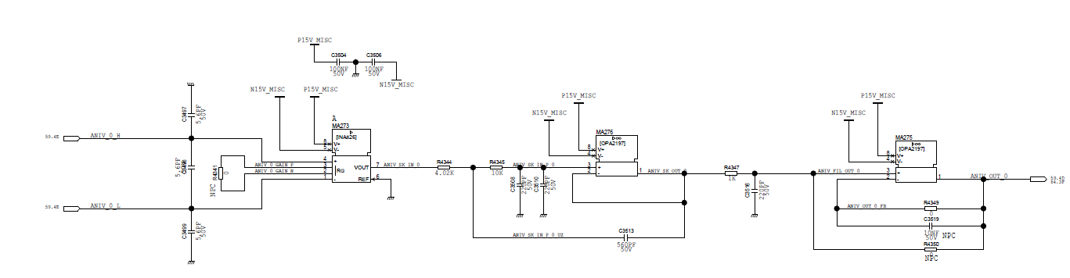

Pre filter (EMI) to insert or not?: